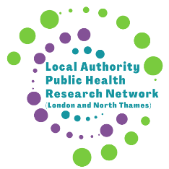Conference Submission Guidelines
The purpose of the conference is sharing ideas, learning and developing networks. To this end, we welcome submissions not just on completed work, but also on work individuals and teams are currently doing, or would like to do and seek collaborations.
Deadline for submissions: 31 December 2023 BUT please do feel free to email us to discuss or seek advice on an idea for submission (include in the title of email LAPHRN conference abstract)
Abstract Length: 350 words
Topic
Informed by members and the wider research community, we have identified the following priority topics. You can select more than one and do feel free to submit abstracts on other topics.
Public health topics | Methods/approaches
Inequalities  Communities  Climate  Housing  Cost of living  Screening and immunisation  Cross-sector working | Monitoring inequalities  Community-led research  Data  Embedded researchers

Structure
These are suggested headings to structure different types of abstract but it is permissible to adapt these to fit your subject:
- Completed work: Background, Objectives, Methods, Results, Discussion/Learning for wider community
- Work in progress: Background, Objectives, Stage At Submission, Methods, Learning so far/Discussion points
- Seeking collaboration: Background (e.g. work done locally to date), Evidence need (e.g. to find out…) or Goal (e.g. cross-site evaluation), Types of collaboration welcomed (e.g. other LAs doing similar or comparable work, methodological expertise)
- Training session: Background, Learning objective, Session format
- Extended workshop: Background, Session format, Any required prior engagement or experience from those attending this session (e.g. pre reading)

